## **NewsWise: AI-Powered Contextualized News Feed - Phase 1 Deliverables**

### **1. Synopsis Document**

**Project Name:** NewsWise: AI-Powered Contextualized News Feed

**Introduction:**

In today's fast-paced information world, people are overwhelmed by the sheer number of news stories. Navigating this terrain to get relevant, trustworthy, and fair information is a major problem. Furthermore, comprehending complicated issues and spotting potential biases in news sources needs considerable effort and critical thought. NewsWise seeks to solve these issues by offering a tailored and contextualized news experience.

**Problem Statement:**

* Information Overload: Users struggle to find relevant news amidst the overwhelming amount of content.
* Lack of Context: News articles often lack sufficient context, making it difficult to understand the nuances of complex topics.
* Bias Detection: Identifying and understanding potential biases in news articles is challenging.
* Personalization Limitations: Existing news aggregators often lack sophisticated personalization capabilities, resulting in generic news feeds.

**Objectives:**

* **Personalized News Feed:** Provide a news feed tailored to individual user interests and preferences.
* **Contextual Understanding:** Utilize AI to analyze news articles and extract key information, including topics, entities, and sentiments.
* **Bias Detection:** Identify and highlight potential biases within news articles, promoting media literacy.
* **Explanation Generation:** Generate simplified explanations of complex topics to enhance user understanding.
* **User Empowerment:** Empower users to make informed decisions by providing contextualized information and insights.
* **Modular Architecture:** Develop a scalable and maintainable system using microservices.

**Scope of the Project:**

This project encompasses the development of the following core functionalities:

* **News Aggregation:** Fetching news articles from various sources (APIs, RSS feeds, web scraping).
* **Contextualization:** Utilizing an LLM to extract context, identify entities, detect biases, and generate summaries.
* **Personalization:** Recommending news articles based on user interests and article context.
* **User Management:** Managing user profiles, interests, and preferences.
* **API Gateway:** Providing a unified entry point for accessing microservices.
* **Service Discovery:** Implementing service discovery to enable communication between microservices.
* **Configuration Management:** Enabling centralized configuration of microservices.

**Technologies Used:**

* **Programming Language:** Java
* **Framework:** Spring Boot
* **Database:** MySQL (with Spring Data JPA)
* **Microservices Architecture:** Utilizing RESTful APIs
* **API Client:** Spring WebClient
* **Web Scraping (Optional):** Jsoup (If required for specific news sources)
* **LLM Integration:** OpenAI Java SDK (or similar)
* **Service Discovery:** Eureka
* **API Gateway:** Spring Cloud Gateway
* **Configuration Management:** Spring Cloud Config
* **Authentication & Authorization:** Spring Security, JWT (Recommended)
* **Caching:** Spring Cache
* **Scheduling:** Spring Scheduler
* **Version Control:** Git (with GitHub)
* **Containerization:** Docker
* **Orchestration:** Kubernetes (EKS on AWS)
* **Monitoring:** Spring Boot Actuator, Micrometer, Prometheus, Grafana (ELK Stack or AWS CloudWatch for logging)
* **Resilience:** Resilience4J
* **Cloud Platform:** AWS

**Expected Outcome:**

* A functional and scalable AI-powered personalized news aggregator.
* A modular system utilizing microservices for maintainability and scalability.
* A user-friendly interface for accessing personalized news feeds, managing interests, and adjusting preferences.
* Integration with external news sources via API calls, RSS feeds, and web scraping (if necessary).
* Implementation of core features like context extraction, bias detection, and summarization using an LLM.
* Secure user authentication and authorization.
* Clear documentation for deployment, maintenance, and future development.

### **2. ERD (Entity-Relationship Diagram)**

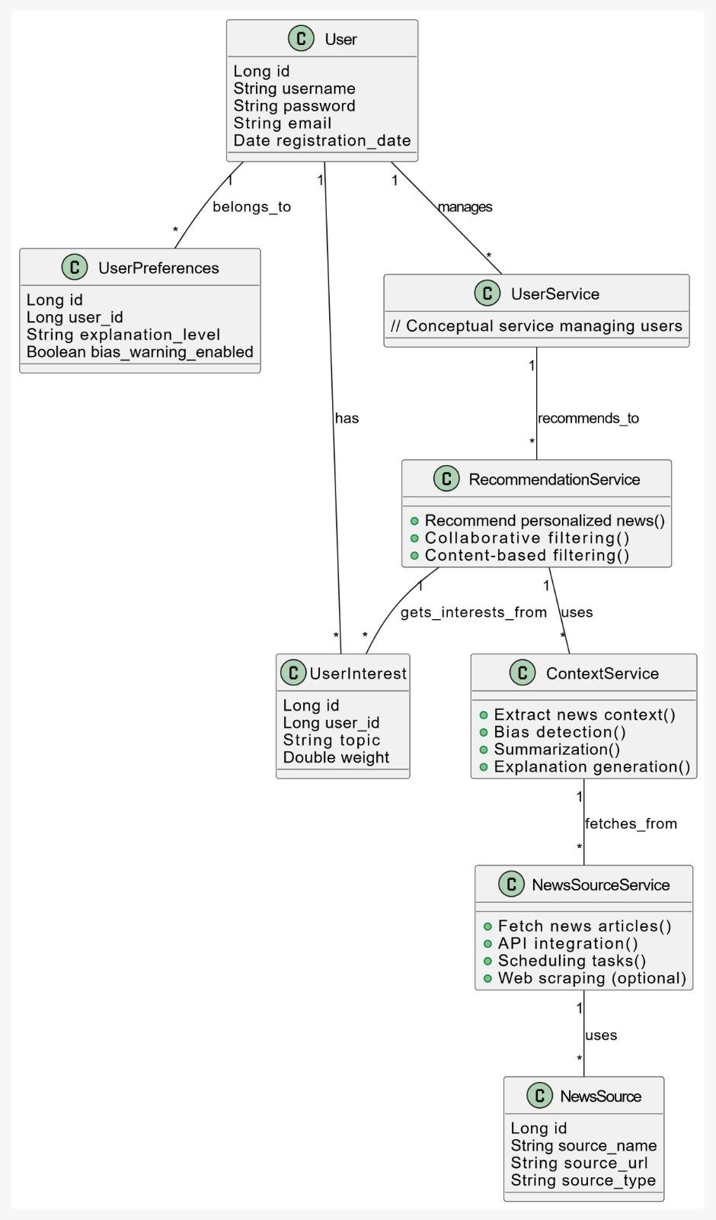

**Explanation of ERD:**

* **Entities:** User, UserInterest, UserPreferences, NewsSource (Optional)
* **Relationships:**
  + User can have multiple UserInterest (One-to-Many).
  + User has one UserPreferences (One-to-One).
  + UserInterest belongs to one User (Many-to-One).
  + UserPreferences belong to one User (Many-to-One).
  + NewsSourceService uses NewsSource (if configured)
  + ContextService uses information fetched from NewsSourceService
  + RecommendationService uses information provided by the UserService and ContextService
  + UserService manages User accounts
* **Primary Keys (PK):** id for all tables, autogenerated.
* **Foreign Keys (FK):**
  + user_id in UserInterest and UserPreferences tables referencing User.id.
* **Unique Key (UK):** username in the User table.
* **Normalization:** The database design adheres to normalization principles. Specifically:
  + **1NF (First Normal Form):** Each table contains atomic values. No repeating groups.
  + **2NF (Second Normal Form):** In addition to 1NF, all non-key attributes are fully functionally dependent on the primary key.
  + **3NF (Third Normal Form):** In addition to 2NF, no non-key attributes are transitively dependent on the primary key (i.e., no dependencies on other non-key attributes).
* **Microservices and Data Flow:** The diagram illustrates the interactions of different microservices without specifying the exact content of their databases (which are mostly service-specific, outside the core User data). The arrows show how information flows between them.